What do I need to know about getting vaccinated?

COVID-19 Information for Multicultural LGBTIQ+ Communities

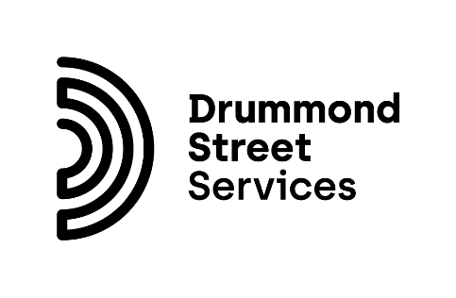

**Please note:** This document contains text that has been formatted as headings, as well as in bold and italics.

If you are using a screen reader, we recommend checking your settings to make sure that it reads out or emphasises formatted text. (If you are using Windows, instructions on how to do this are on [the Narrator support website](https://support.microsoft.com/en-us/windows/chapter-7-customizing-narrator-ce950246-c915-0d44-9be6-fb474387a285).)

# You’ll be protecting yourself and others

When you get fully vaccinated against COVID-19:

* You’re **less likely to catch** COVID-19
* You’re **less likely to spread** COVID-19 to others
* You’re **less likely to get very sick** if you do catch COVID-19
* You’re **helping protect people** who can’t get vaccinated for medical reasons

The more people that are vaccinated, the fewer people will catch the virus, spread the virus, get sick or die.

# You’ll be able to get back to everyday life

You may need to be vaccinated to:

* [Participate in some everyday activities or use some everyday services](https://www.coronavirus.vic.gov.au/victorias-roadmap)
* [Continue going to work](https://www.coronavirus.vic.gov.au/information-workers-required-be-vaccinated)
* [Travel overseas](https://www.smartraveller.gov.au/COVID-19/COVID-19-vaccination-certificates)

# Are the vaccines safe?

All available vaccines in Australia:

* Are safe and effective
* Have been tested on large numbers of people internationally
* Have passed [the strict safety standards](https://www.tga.gov.au/covid-19-vaccines) set by Australia’s independent medicines regulator, the Therapeutic Goods Administration

# Should I wait for a vaccine that isn’t currently available in Australia?

There are three vaccines available in Australia – **AstraZeneca**, **Moderna** and **Pfizer**. There’s no guarantee that any other vaccines will be approved for use in Australia.

**It’s best to get one of the currently available vaccines.**

# I don’t have a Medicare card or I am on a visa – can I get vaccinated?

COVID-19 vaccines are **free for everyone** in Australia, including:

* Refugees
* People seeking asylum
* Temporary and provisional visa holders
* International students
* Temporary migrants

[**You don’t need a Medicare card or an Individual Healthcare Identifier (IHI)**](https://www.coronavirus.vic.gov.au/checklist-your-covid-19-vaccination#you-don%E2%80%99t-need-a-medicare-card-to-access-a-free-covid-19-vaccine) to get a COVID-19 vaccine.

Getting a COVID-19 vaccine **will not affect your visa status or eligibility for government payments**.

# I’ve had COVID-19 and recovered from it – should I still get vaccinated?

**Yes**, you should still get vaccinated after you have recovered from COVID-19.

# Is it safe to get vaccinated if:

## I’m on hormone therapy?

Yes, it’s safe if you’re taking a prescribed form of hormone therapy.

## I’m taking PrEP?

Yes, it’s safe if you’re taking pre-exposure prophylaxis (PrEP) medications.

## I’m on antiretrovirals?

Yes, it’s safe if you’re taking antiretrovirals.

## I’m taking other medication or have a medical condition?

In many cases, yes. Talk to your doctor or healthcare provider about your vaccination options.

# What can I do if I have a bad experience when I get vaccinated?

You can [make a complaint](https://www.dhhs.vic.gov.au/making-complaint) to the Victorian Department of Health about any service provided by the department or a service provider funded by the department. This includes public vaccination centres.

# About this fact sheet

Drummond Street Services acknowledge the Traditional Owners of the land where we work and pay respects to Elders past and present.

This fact sheet is part of a series of fact sheets from Drummond Street Services and Queerspace. You can find our other fact sheets in English and other languages on [the Centre for Family Research and Evaluation website](https://cfre.org.au/lgbtiq-covid/).

The information in this fact sheet is current at 29 October 2021.

Information comes from the Victorian Department of Health and the Australian Department of Health.

You can get more information about COVID-19 safety and vaccines in other languages from [the Victorian Government website](https://www.coronavirus.vic.gov.au/translated-information-about-covid-19-vaccines) and [the Australian Government website](https://covid19inlanguage.homeaffairs.gov.au/).